Information Gathering:
LAB:
- Download the application xmind from (https://xmind.app)
- Using OSINT, gather information about “Telenor Pakistan”
  - Company Name
  - Key Services/Product
  - Scope of Services
  - Website
    - Fully Qualified Domain Name
    - Hosting Country/Company
    - Age
    - IP Address
    - Geo Location of Web Server (longitude/latitude)
    - Technologies
    - Load Balancer / Web Application Firewall (WAF), if any
- Content Delivery Network (if any)
- Sub-domains
- Domain Registrar
- Shared Hosting (if any)

Now where to gather this information?
If you have Company name, go to Wikipedia for information like “Key services/Products, Scope of Services and its Fully Quantified Domain Name”. Now go to the site Netcraft > Resources > Research tools > Site Report. Enter the name of the domain like www.telenor.com.pk.
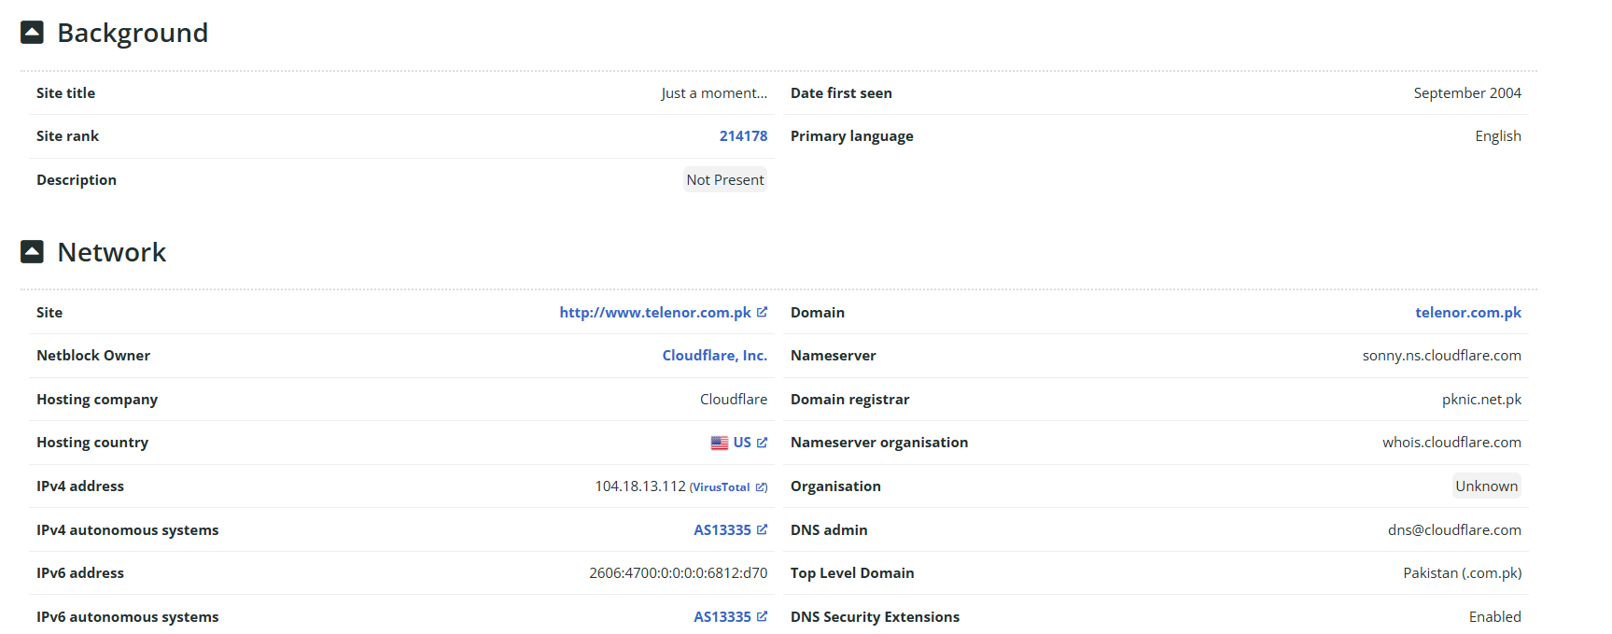
This site will tell you information like Hosting Country, Company, IP Address and some other info.
To find Geolocation, go to the site named IP2Location, put the IP there and it will tell you the Country, Region, City and Coordinates and some other info.
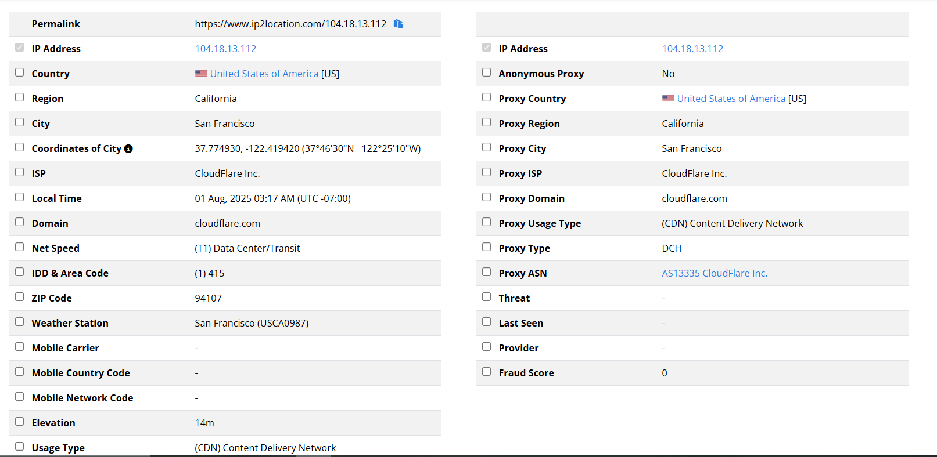
For information about Technologies like which technology are they using, use the Wapplyzer extension.
To find about Web Application Firewall and Load Balancers, we have built-in tools in Kali Linux.
Type this in terminal to find info about WAF:
wafw00f www.telenor.com (It will tell you if they are using WAF)
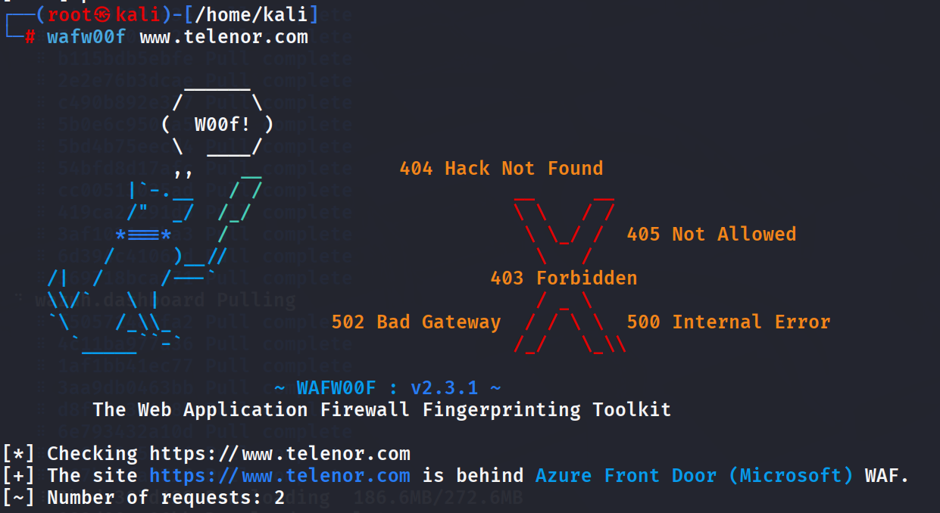
Type this in terminal to find info about Load Balancer:
lbd Telenor.com (It will tell you if they are using Load Balancer)
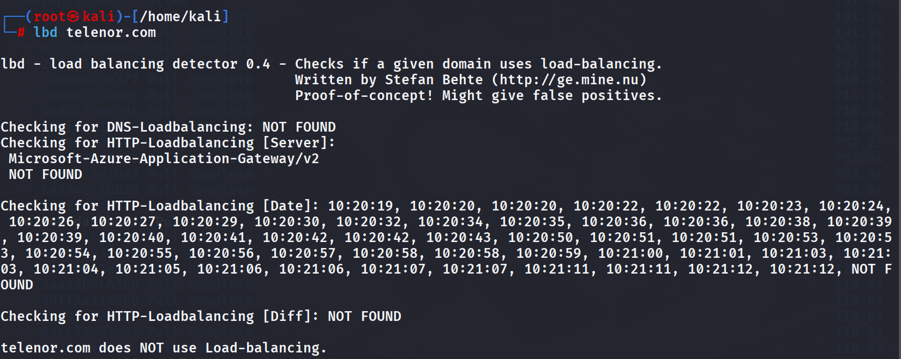

Note: There are other tools for cross-checking like WMtips, Webcheck, URLscan.io (This one is more authentic)

Finding Sub-Domains:
Tools for finding Sub-domains:
- Subdomain finder (Web-based)
- Assetfinder (Linux-based)
  - Install it by typing apt install assetfinder
- Subfinder (Linux-based)
  - Install it by typing apt install subfinder
- Crt.sh (Web-based)
- Amass
LAB:
- Find out sub-domains of Telenor.com.pk using tools mentioned above.
- Validate active sub-domains using httprobe, httpx(requires golang dependency), & httpx-toolkit.
- Compare the output(active-domains) using an appropriate tool to build a final list for sub-domains.

Procedure:
1. Find the sub-domains about the target using tools.
e.g: subfinder -d Telenor.com.pk
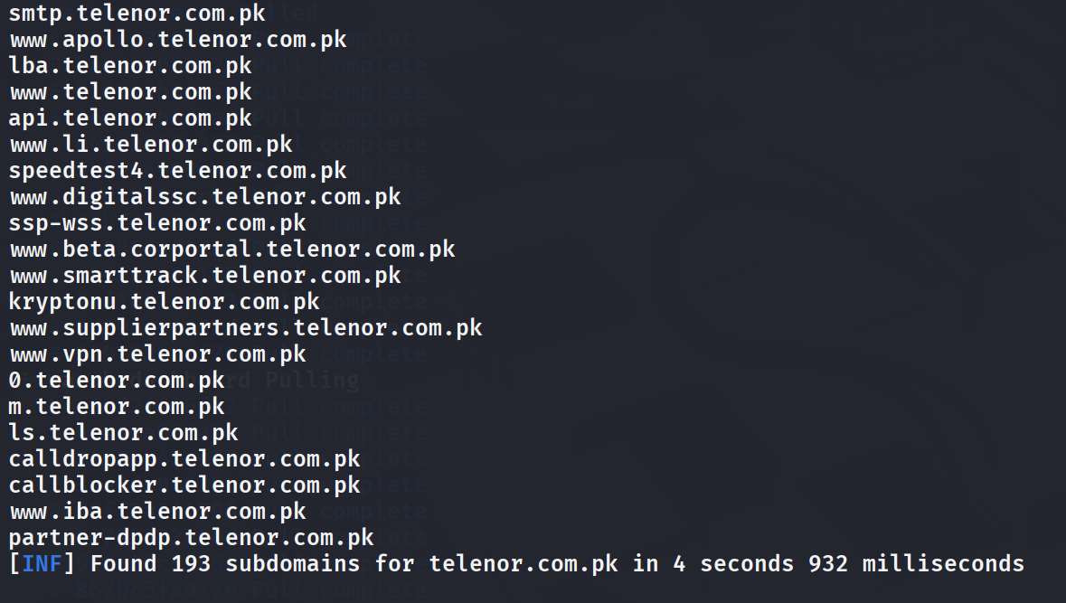
2. Copy these sub-domains and save them in a file. Suppose filename is sub-domains.txt
3. Now verify the active sub-domains using tool httprobe using this command:
cat sub-domains.txt | httprobe
4. This will send probe request to every sub-domain and if he gets response he will list active sub-domains.

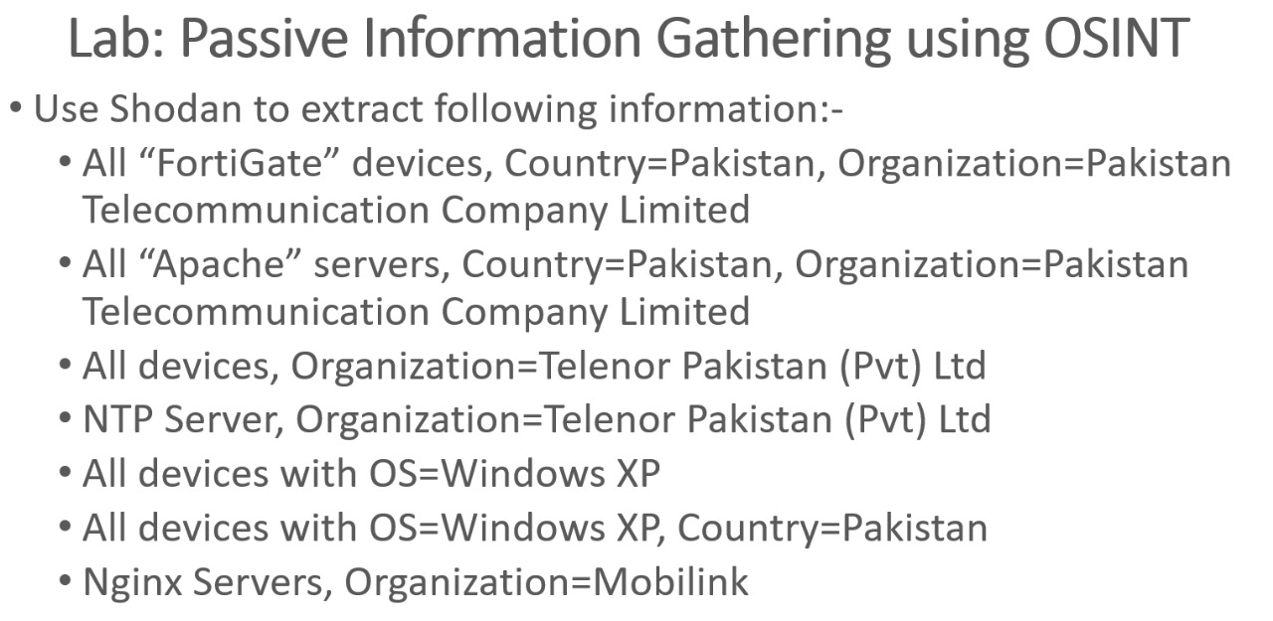
Suppose you want to know how many or which devices Ptcl has on its premises. This is the procedure:
- Go to Shodan.io
- Search like this cisco country:pk. This will tell you how many cisco devices are in Pakistan. Then we can also check devices in specific cities.
- Similarly, type fortigate country:pk. It will tell you how many fortigate products are in Pakistan with their IP.
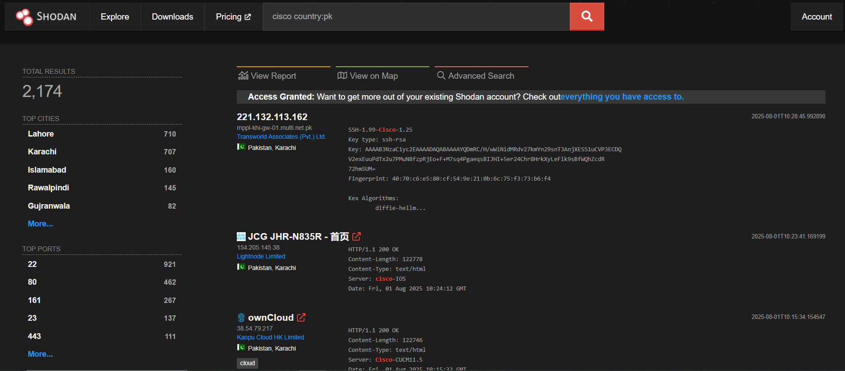

Packet Analysis using Wireshark:
We will be capturing packets from the Login page of Vulnerable web.
- Open Wireshark and start capturing packets.
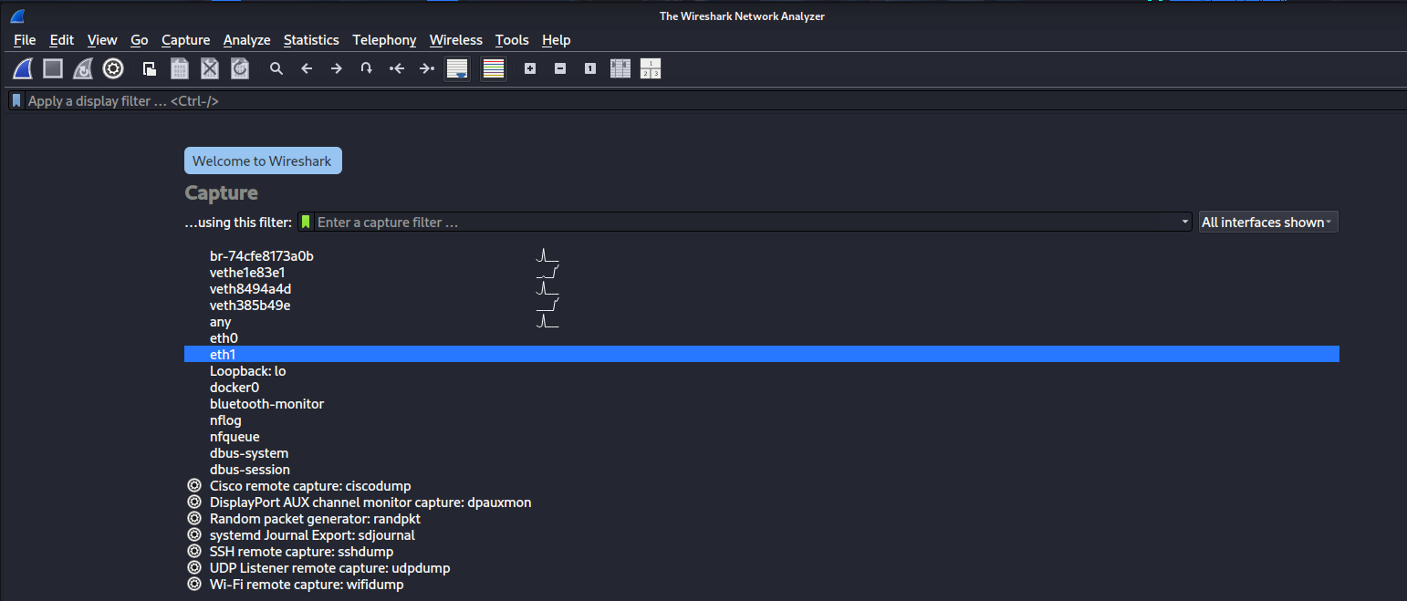
- Go to the login page of the site and enter any credentials.
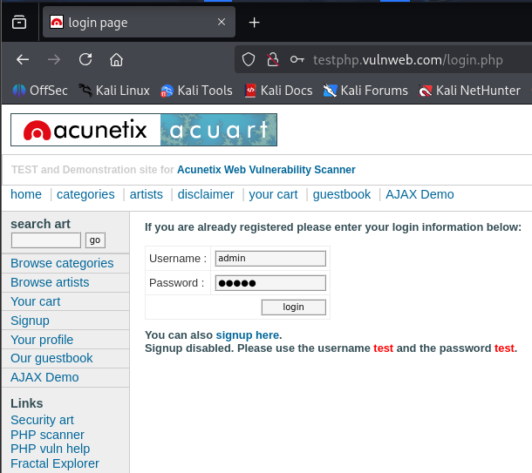
- You will see wireshark will start capturing packets.

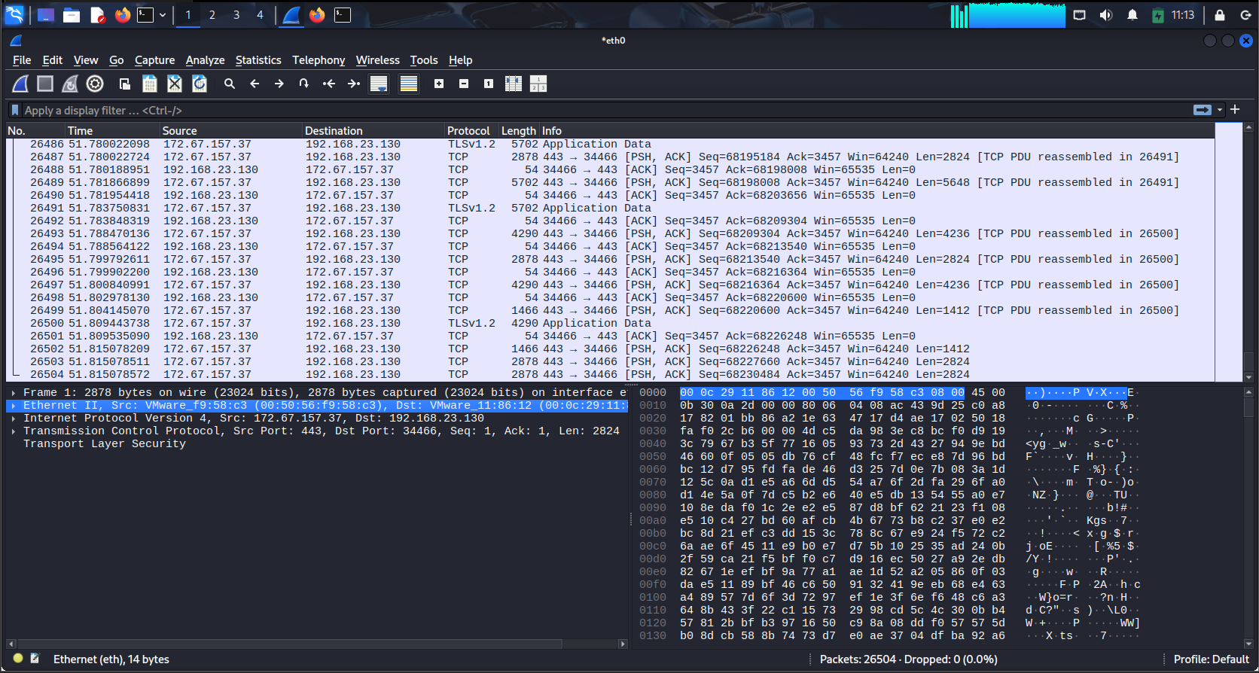

- Apply a filter to filter out ‘POST’ request.

- Right click on it and follow HTTP stream.
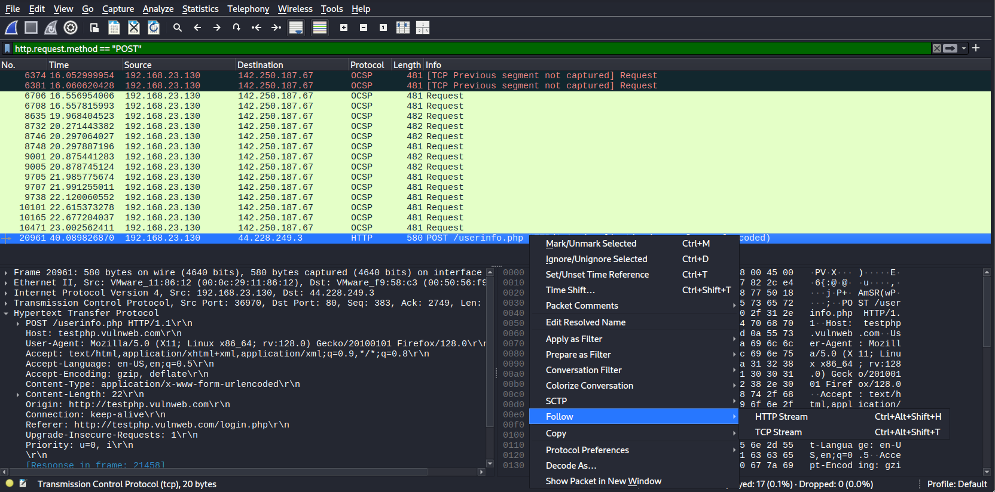
- Scroll down until you see credentials.
